VULNERABILITY
ASSESSMENT OF
TEST NETWORK

ApexPlanet Software Pvt. Ltd.
Cybersecurity & Ethical Hacking Internship

Prepared By: Pooja Ramcharitra Yadav

ABSTRACT
Vulnerability Assessment is a critical process in cybersecurity used to identify, evaluate, and prioritize security weaknesses within a network. This project focuses on performing a vulnerability assessment of a controlled test environment using Kali Linux and Metasploitable2. Various security tools such as Nmap and Nikto were used to discover open ports, identify running services, detect vulnerabilities, and analyze potential security risks. The findings reveal multiple critical vulnerabilities and insecure services that could allow attackers to gain unauthorized access or compromise system security. Appropriate mitigation strategies are proposed to improve the overall security posture.

TABLE OF CONTENTS
- Introduction
- Objectives
- Scope
- Tools Used
- Network Architecture
- Methodology
- Network Discovery
- Port Scanning
- Service Enumeration
- Vulnerability Assessment
- Findings
- Risk Analysis
- Recommendations
- Conclusion
- References

1. INTRODUCTION
Cybersecurity threats continue to increase as organizations become more dependent on networked systems and online services. Vulnerability Assessment is a proactive approach used to identify weaknesses before they can be exploited by malicious actors.
The objective of this project is to evaluate the security posture of a test network by discovering open ports, identifying services, detecting vulnerabilities, and providing mitigation recommendations.

2. OBJECTIVES
The objectives of this project are:
- To perform network discovery and host identification.
- To identify open ports and services.
- To perform service enumeration.
- To detect vulnerabilities using automated scanning tools.
- To analyze security risks associated with discovered vulnerabilities.
- To recommend appropriate mitigation strategies.

3. SCOPE
Target System:
Metasploitable2
Target IP Address:
192.168.56.102
Assessment Machine:
Kali Linux
Assessment IP Address:
192.168.56.101
Assessment Type:
Internal Vulnerability Assessment

4. TOOLS USED
Tool | Purpose
Kali Linux | Security Testing Platform
Metasploitable2 | Vulnerable Target Machine
Nmap | Network Scanning
Nikto | Web Server Assessment
Firefox | Web Interface Testing

5. NETWORK ARCHITECTURE
Network Configuration:
Kali Linux (192.168.56.101)
↓
Host-Only Network
↓
Metasploitable2 (192.168.56.102)
[Insert Network Diagram Screenshot Here]

6. METHODOLOGY
The project followed the following methodology:
- Network Discovery
- Port Scanning
- Service Enumeration
- Vulnerability Assessment
- Risk Analysis
- Mitigation Recommendations
- Reporting

7. NETWORK DISCOVERY
Network connectivity was verified using ICMP Ping.
Command Used:
ping -c 4 192.168.56.102
Result:
- Host reachable
- 0% packet loss
- Average latency below 3 ms
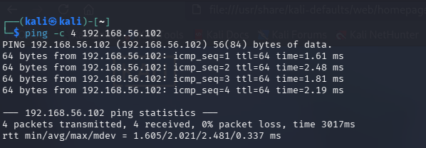

8. PORT SCANNING
Command Used:
sudo nmap -Pn -n 192.168.56.102
Results:
A total of 23 open TCP ports were identified.
Open Ports:
21 FTP
22 SSH
23 Telnet
25 SMTP
53 DNS
80 HTTP
111 RPCBind
139 NetBIOS
445 SMB
512 rexec
513 rlogin
514 rsh
1099 Java RMI
1524 Backdoor Shell
2049 NFS
2121 FTP
3306 MySQL
5432 PostgreSQL
5900 VNC
6000 X11
6667 IRC
8009 AJP13
8180 HTTP
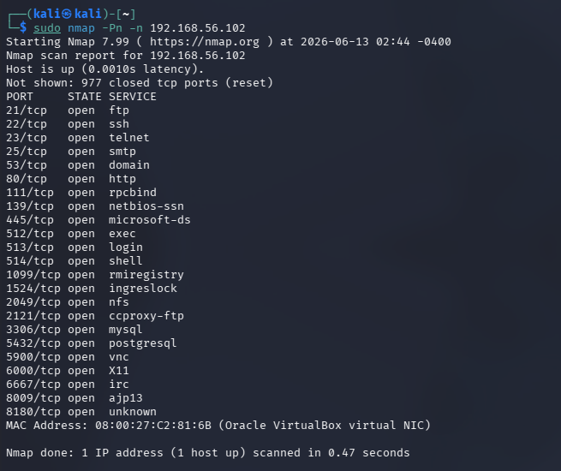

9. SERVICE ENUMERATION
Command Used:
sudo nmap -Pn -n -sV 192.168.56.102
Detected Services:
FTP: vsFTPd 2.3.4
SSH: OpenSSH 4.7p1 Debian
Telnet: Linux telnetd
SMTP: Postfix smtpd
DNS: ISC BIND 9.4.2
HTTP: Apache httpd 2.2.8
SMB: Samba smbd 3.x
MySQL: MySQL 5.0.51a
PostgreSQL: PostgreSQL 8.3
Tomcat: Apache Tomcat/Coyote JSP Engine
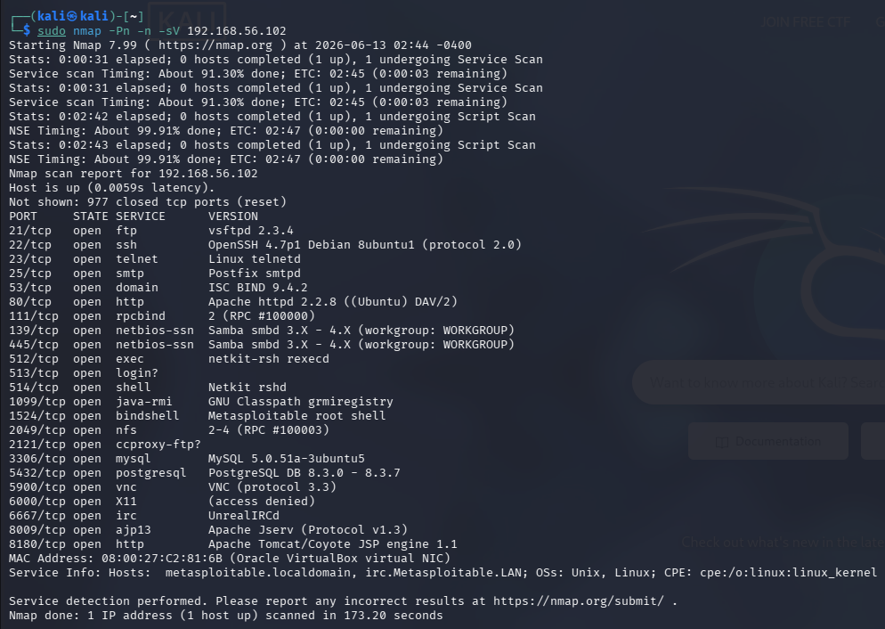

10. VULNERABILITY ASSESSMENT
Command Used:
sudo nmap -Pn -n --script vuln 192.168.56.102
Nikto Scan:
nikto -h http://192.168.56.102
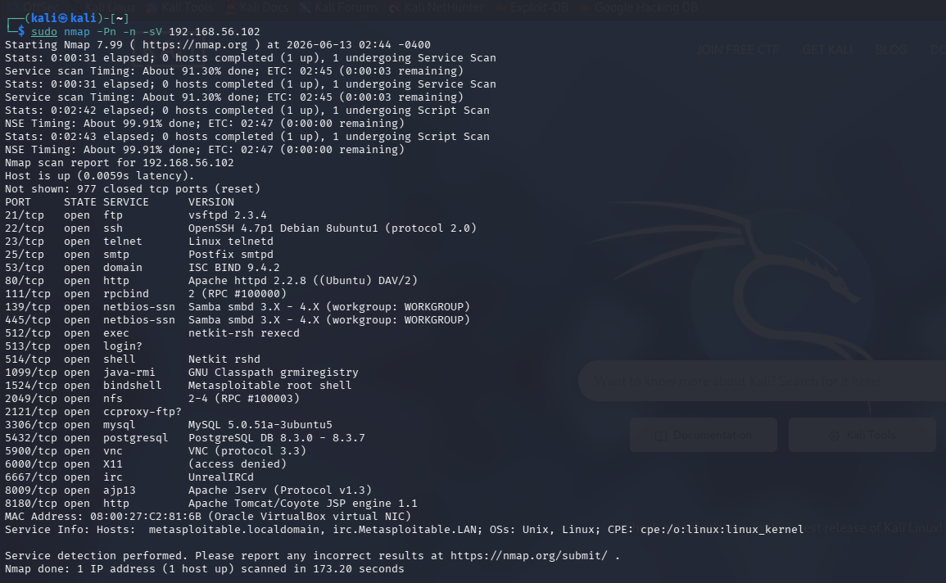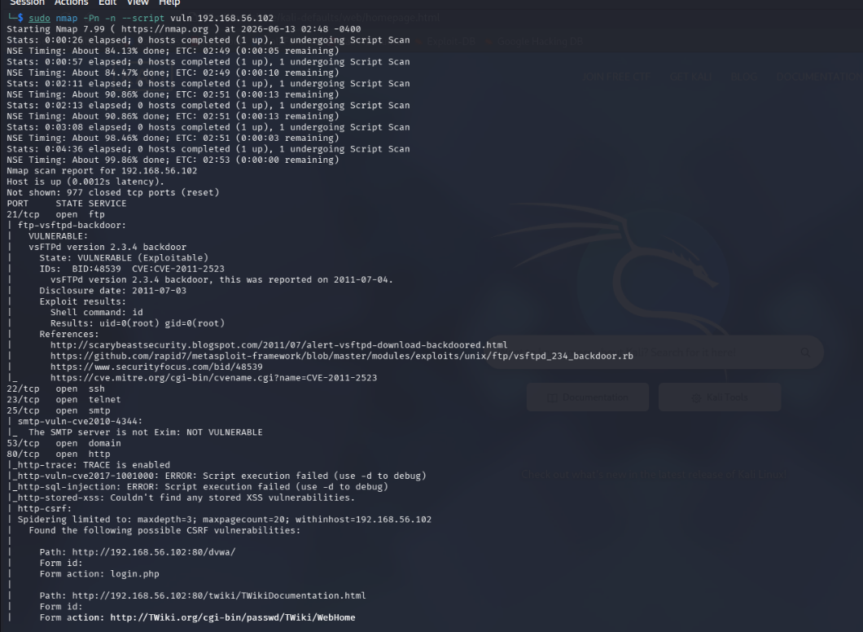
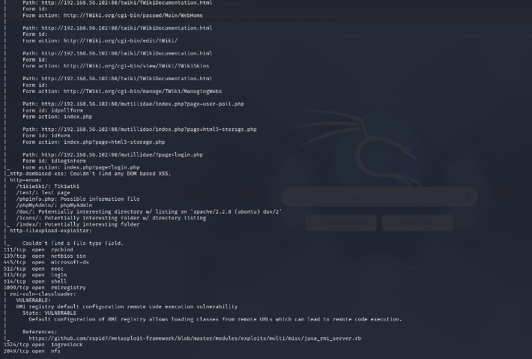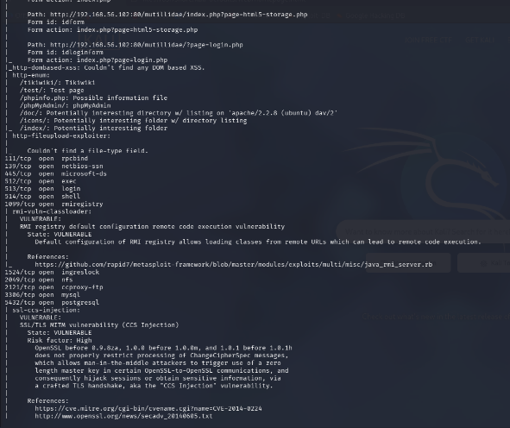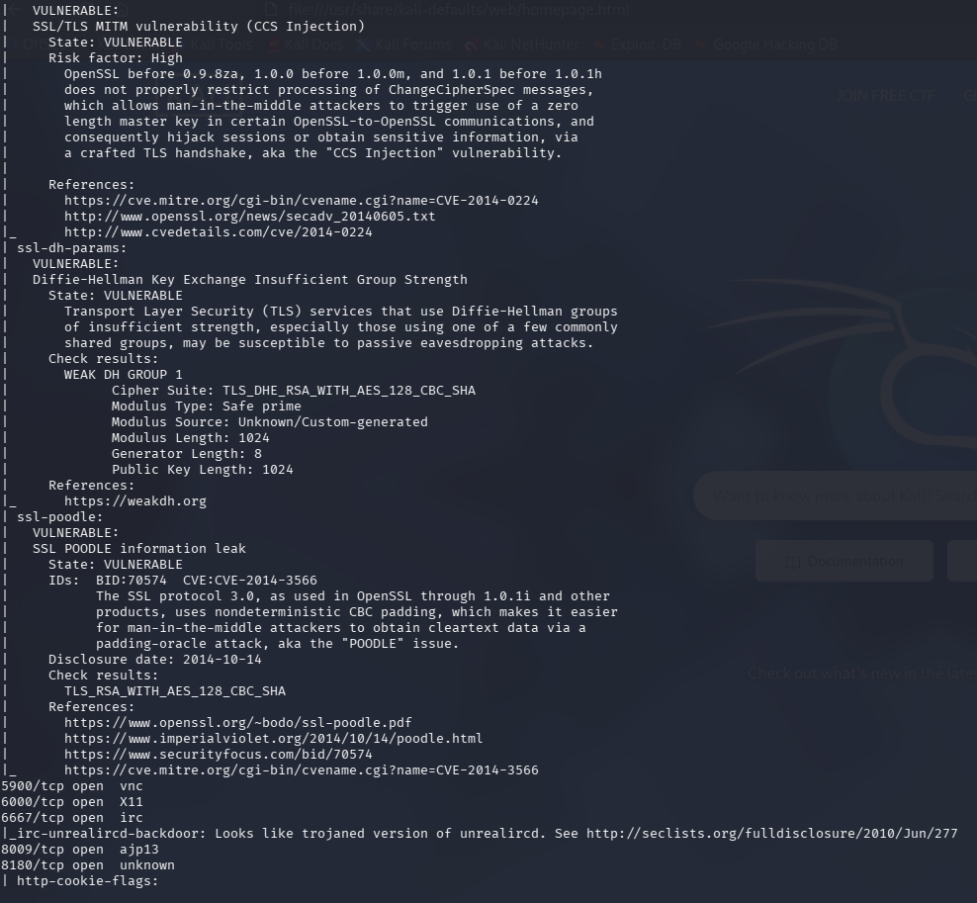

11. FINDINGS
Finding 1: VSFTPD Backdoor Vulnerability
Service:
FTP
Version:
vsFTPd 2.3.4
CVE:
CVE-2011-2523
Severity:
Critical
Impact:
Allows remote attackers to gain unauthorized shell access.
Finding 2: Java RMI Remote Code Execution
Port:
1099
Severity:
Critical
Impact:
Allows execution of arbitrary code remotely.

Finding 3: Telnet Service Enabled
Port:
23
Severity:
Critical
Impact:
Credentials transmitted in plaintext.

Finding 4: SMB Exposure
Port:
445
Severity:
High
Impact:
Information disclosure and remote exploitation.

Finding 5: HTTP TRACE Enabled
Severity:
Medium
Impact:
Cross-Site Tracing attacks and information disclosure.

Finding 6: Directory Listing Enabled
Directories Found:
/doc/
/icons/
/index/
Severity:
Medium
Impact:
Exposure of sensitive information.

Finding 7: PHP Information Disclosure
File Found:
phpinfo.php
Severity:
Medium
Impact:
Server configuration information leakage.

Finding 8: Weak SSL/TLS Configuration
Issues Identified:
- POODLE Vulnerability
- CCS Injection
- Weak Diffie-Hellman Groups
Severity:
High
Impact:
Man-in-the-Middle attacks and encrypted traffic compromise.

12. RISK ANALYSIS
Vulnerability | Severity
VSFTPD Backdoor | Critical
Java RMI RCE | Critical
Telnet Enabled | Critical
SMB Exposure | High
Weak SSL/TLS | High
HTTP TRACE Enabled | Medium
Directory Listing | Medium
PHP Info Disclosure | Medium
13. RECOMMENDATIONS
Critical Recommendations:
- Remove VSFTPD 2.3.4 and upgrade FTP service.
- Disable Java RMI services if not required.
- Disable Telnet and use SSH.
- Restrict SMB access.
- Remove unnecessary services.
High Priority Recommendations:
- Upgrade Apache Web Server.
- Upgrade OpenSSL.
- Disable weak TLS protocols.
- Restrict MySQL and PostgreSQL access.
Medium Priority Recommendations:
- Disable HTTP TRACE.
- Disable directory listing.
- Remove phpinfo.php.
- Implement regular vulnerability scanning.

14. CONCLUSION
The vulnerability assessment successfully identified multiple security weaknesses within the target system. Several critical vulnerabilities, including the VSFTPD Backdoor, Telnet exposure, Java RMI Remote Code Execution, and weak SSL configurations, were discovered. These vulnerabilities significantly increase the attack surface and could lead to unauthorized access, information disclosure, and system compromise.
The implementation of the recommended mitigation strategies will reduce security risks and improve the overall security posture of the environment. This project provided valuable hands-on experience in vulnerability assessment, security analysis, and cybersecurity reporting.

15. REFERENCES
- Nmap Documentation
- Nikto Documentation
- CVE Database
- OWASP Testing Guide
- Kali Linux Documentation
- Metasploitable2 Documentation

